2009 Petite Sirah

VARIETIES: | 100% Petite Sirah | 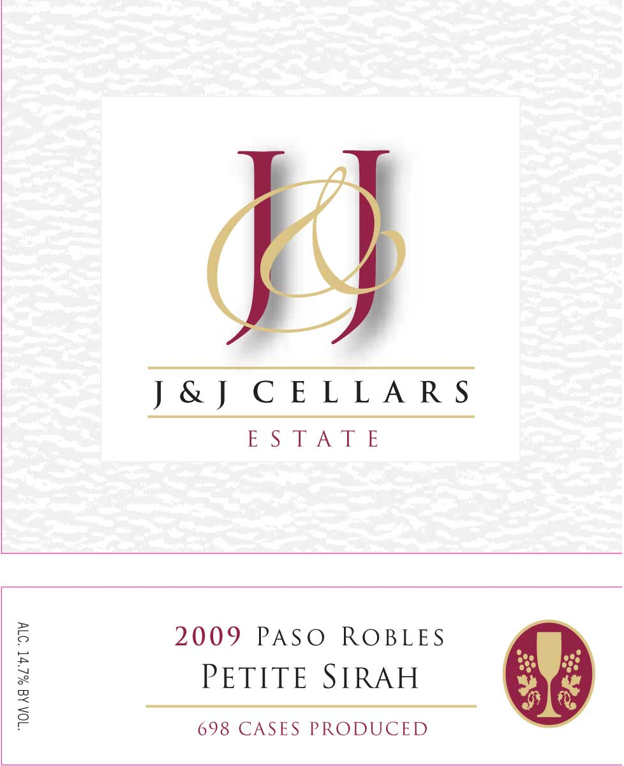
APPELLATION: | Paso Robles
VINEYARD: | San Miguel Estate
ALCOHOL: | 14.7%
ACIDITY: | 6.45g/L
pH: | 3.79
CASES PRODUCED: | 698
GROWING CONDITIONS
The 2009 vintage began with average temperatures and slightly lower than normal winter rainfall. A late spring frost came in April and slowed vine growth. However, warmer temperatures returned in May. Aside from late rain in mid-October, the duration of the vintage was uniform leading to a long growing season. Harvest at J&J stretched from early September to late November. The longer hang-times allowed for optimal berry development. The resulting wines are deeply colored with significant tannic structure and powerful aromatic intensity.
WINEMAKING
Our grapes were harvested in the cool early morning hours and brought to the winery where they were de-stemmed and crushed into a stainless steel fermenter. After 24 hours the must was inoculated and pumped over 2-3 times daily through the duration of primary fermentation. The grapes were pressed and upon completion of malolactic fermentation the wine was aged in a combination of French and American Oak, (30% new) for 11 months prior to bottling.

TASTING NOTES

